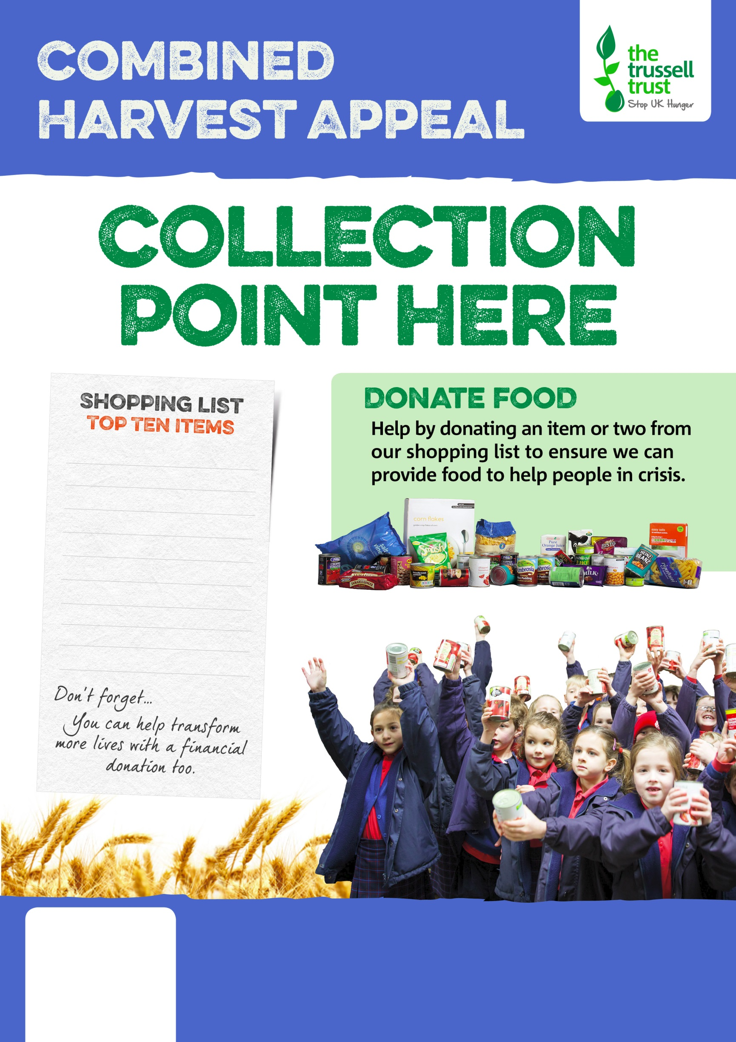
tinned fish
instant coffee
tinned meat
cup-a-soup
tinned rice pudding
biscuits
tinned meals
long life fruit juice
bar of chocolate
shampoo, deodorant

Salisbury Foodbank
salisbury.foodbank.org.uk
Registered Charity in England & Wales (1110522)
Registered Charity in Scotland (SC044256)

