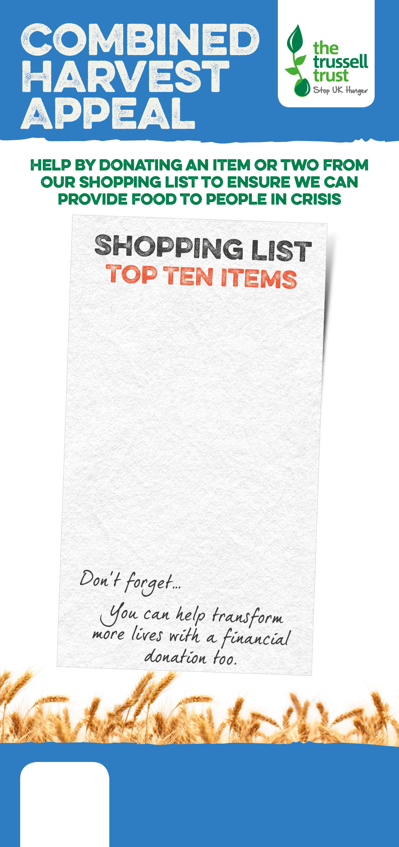

Salisbury Foodbank
salisbury.foodbank.org.uk
Registered Charity in England & Wales (1110522)
Registered Charity in Scotland (SC044246)

)

Salisbury Foodbank
salisbury.foodbank.org.uk
Registered Charity in England & Wales (1110522)
Registered Charity in Scotland (SC044246)

)

Registered Charity in England & Wales (1110522)
Registered Charity in Scotland (SC044246)

Salisbury Foodbank
salisbury.foodbank.org.uk
tinned fish
instant coffee
tinned meat
cup-a-soup
tinned rice pudding
biscuits
tinned meals
long life fruit juice
bar of chocolate
shampoo, deodorant

tinned fish
instant coffee
tinned meat
cup-a-soup
tinned rice pudding
biscuits
tinned meals
snacks
bar of chocolate
shampoo, shower gel

tinned fish
instant coffee
tinned meat
cup-a-soup
tinned rice pudding
biscuits
tinned meals
long life fruit juice
bar of chocolate
shampoo, deodorant

